Student Name: __________________
Class and Section __________________
Total Points (15 pts) __________________
Due: November 3, 2010 before the class

Project: Comparing loans with various interest rates

CSCI 1302 Advanced Programming Principles
Armstrong Atlantic State University

Problem Description:
Rewrite Exercise 5.21 to create a user interface, as shown in the following figure. Your program should let the user enter the loan amount and loan period in number of years from a text field, and should display the monthly and total payments for each interest rate starting from 5 percent to 8 percent, with increments of one-eighth, in a text area.

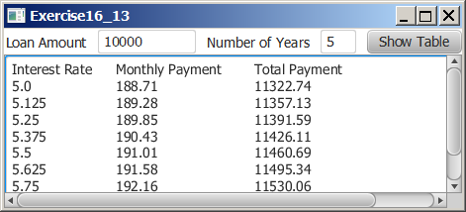
Design:
(Draw a sketch of UI)

Coding:
Name your main class Exercise16_13

Screen shots:

Submit the following items:

1. Submit a hard copy of this document.

2. Compile and Submit to LiveLab as Exercise16_13 (you must submit the program regardless whether it complete or incomplete, correct or incorrect)

3. Fill in self-evaluation:

- Is the UI created correctly?
- Are the values computed correctly?
- Is the table displayed correctly?

